DVDShrink Guide
DVD Shrink Guides by mrbass
Dowload DVDShrink 3.2 freeware
English mirror 1.04MB changelog
released July 25, 2004
working on a 3.2 guide..will be out soon
DVD Shrink enables you to copy a DVD very easily. Copying a DVD doesn't get much simpler than this. Put DVD into DVD-ROM or DVD burner. Choose either either a Full Disk (1:1) copy or a main movie only. It'll analyze DVD, encode video files , and finally burn a copy of the dvd to DVD±R media. Thus you have a excellent quality dvd copy of your original DVD.
Major new features of version 3.2 include:
- AEC adaptive error compensation algorithms...Instant Copy quality
- Title removal --- subsitute with still image
- FAT32 partitions ---burn with dvddecrypter now (splits into 1GB chunks)
- DVD-9 burning with Nero 6
Requirements: 256MB RAM, DirectX for video previewing.
DVD Shrink Main movie only Guide
Object is to backup original DVD dual-layered (DVD-9) to a single-layered DVD±R (DVD-5) disc.
Show how to copy 'Pirates of the Carribean' and try to achieve a decent compression ratio for maximum video quality. Original DVD = 7,673MB reduce to 4,464MB. This can be achieved by stripping out menus, extras, DTS sound, foreign audio and elminitating credits.
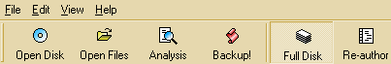
choose either a DVD in your DVD-ROM drive or a ripped .iso image mounted as a virtual drive.
choose ripped video files on your harddisk. You must rip all files.
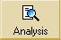Deep Analysis can be done now to show a more precise size calculation of the various titles on the DVD or can be specified in the Backup menu (recommended).
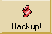After choosing compression level settings, removing audio press Backup! to begin deep analysis, if selected, and the encoding process.
1:1 copy of the dvd including menus and all extras. Choose either Full Disk or Re-author.
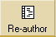Main movie only without menus leaving more bitrate for main movie.
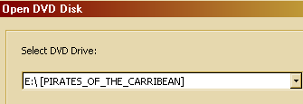
Open Disk select DVD-ROM drive with the DVD inserted OR...
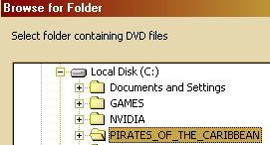
Open Files or point it to ALL files ripped to your harddrive with a dvd ripper.
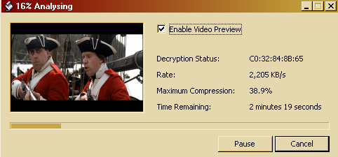
Analysing usually takes a couple minutes for a quick analysis of the DVD.
Click Re-author button
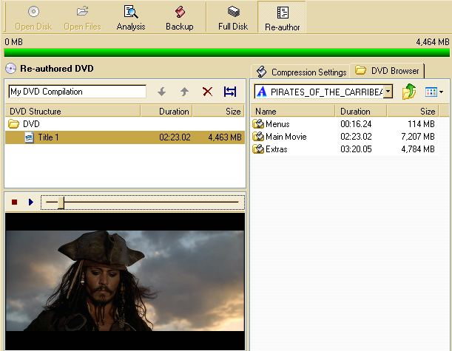Re-author mode creates a custom dvd. You cannot keep menus or the original DVD structure. You can do main movie only and add additional titles (some bonus features or extras for instance) and they'll play sequentially.
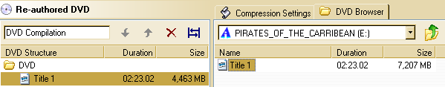
In the right pane double-click on the folder Main Movie then double-click (or drag) on Title 1 to add it to your Re-authored DVD in the left pane.
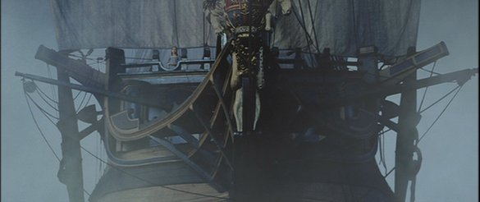
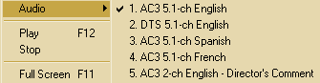
Video Playback with Dolby Digital Sound Decoding (DirectX is required).
Assists in determining which video corresponds to the paticular titles.
Right-click on video to switch Audio streams.
Double-click on video or F11 to switch in and out of Full Screen.
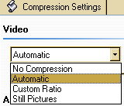
No Compression video remains 100% of original.
Automatic default and recommended. Adjusts automatically when audio streams are deselected.
Custom Ratio drag slider bar or type in percent you wish.
Still Pictures slideshow with sound playing at regular speed. Lowest compression possible.
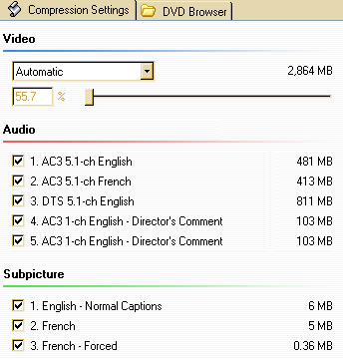
Compression Settings If we started backing it up now we'll have only retained only 55.7% of original size video due to high compression which might be pushing the video quality. Let's attempt to get it the percentage of original video size as high as possible. Subpicture always keep all subtitles as they're insignificant in size.
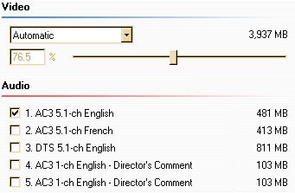
By unchecking all audio except AC3 5.1-ch English we just increased it from 55.7% to 76.5%.
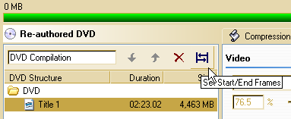
Click Set Start/End Frames and will edit out the credits for even better video quality.
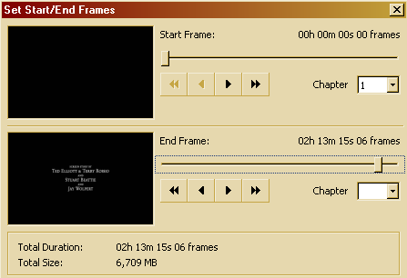
Drag right slider bar to the start of the credits to set the End Frame.
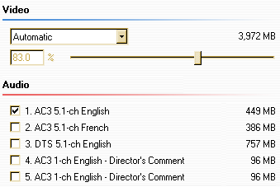
Due to editing out the credits we now have 83% which is excellent video quality. Much better than 55%.
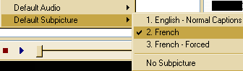
One more optional thing you can do in Re-author mode (not Full Disk) is set a default Audio and Subpicture stream by right clicking on a Title in your left pane. If I choose French as my default subtitle then when I played the dvd french subtitles will automatically play.
Now we're ready to begin backuping up the movie. Click the Backup! button.
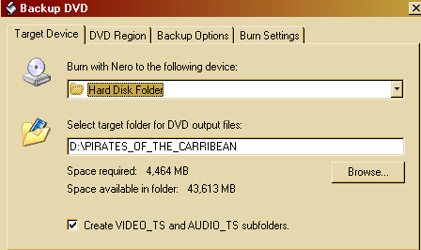
Burn with Nero to the following device:
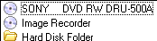
DVD Burner if you wish you can specify a volume label in Burn Settings
Image Recorder be sure to specify volume label, path and nero image file in Burn Settings tab. Image .nrg is Nero's proprietary image format, however, daemon-tools can mount it and DVDDecrypter can burn it. Just like an .iso.
Hard Disk Folder: You can browse to a drive letter on your hardrive and create a new folder OR type in the letter and path and it'll automatically be created once it begins if it's non-existent.
Create VIDEO_TS and AUDIO_TS subfolders. helps if your using a thirdparty burning program. AUDIO_TS folder is created for compatibility on really old dvd players although there'll be nothing inside the folder.
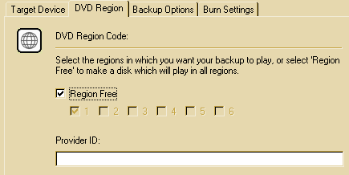
Region Free: check this so your backup DVD will play on all DVD players in any country.
DVD regions:
Region 1 - 1: U.S., Canada, U.S. Territories
Region 2 - Japan, Europe, South Africa, and Middle East (including Egypt)
Region 3 - Southeast Asia and East Asia (including Hong Kong)
Region 4 - Australia, New Zealand, Pacific Islands, Central America, Mexico, South America, and the Caribbean
Region 5 - Eastern Europe (Former Soviet Union), Indian subcontinent, Africa, North Korea, and Mongolia
Region 6 - Peoples Republic of China
Provider ID: just leave blank or leave it whatever it is. It only shows in the .IFO file.
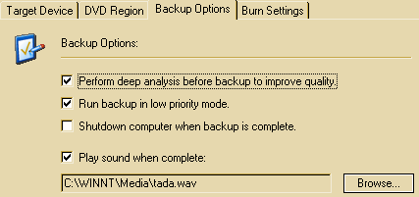
Deep analysis analyzes each and every frame which results in better allocation of where it should transcode.
Run backup in low priority mode. improves responsiveness of computer when multi-tasking.
Shutdown computer when backup is complete. go to bed, if awake you have 2 mins to cancel shutdown process.
Play sound when complete: browse to a .wav sound file on your hard disk.
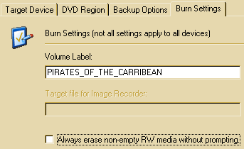
If you choose to burn to your DVD burner you'll have these options available.
Volume Label: shows only in windows explorer. 32 characters maximum. Only ABC123 and _ allowed.
Always erase non-empty RW media without prompting. If unchecked before burning commences it'll ask you whether you wish to overwrite data on your DVD±RW disc.
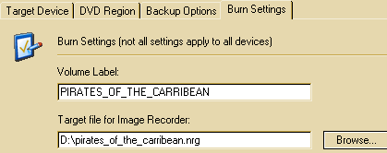
If you choose to burn to Image Recoder you'll have these options available.
Volume Label: shows only in windows explorer. 32 characters maximum. Only ABC123 and _ allowed.
Target file for Image Recorder: You can browse for a location and type in an image file name OR type in a drive letter and path with the image file name with the .nrg extension. If you forget to fill this in at the end of the encoding process a SAVE AS dialog will pop up asking you for the location it should be saved.
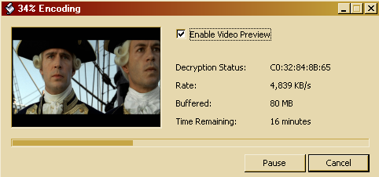
Analysing takes anywhere from 15 to 30 minutes typically.
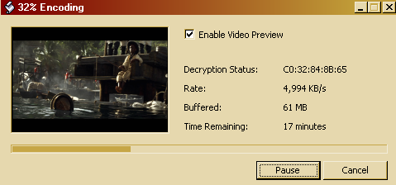
Encoding takes around 20 to 45 minutes depending on I/O and speed of computer.
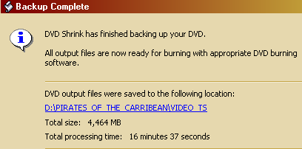
Your done. If you have burned your dvd you can click the link and delete those files.

