DVDXCOPY improvements - or how to remove .VOB ID's
I have successfully removed the 321 disclaimer that takes about 7 seconds to play at the start of a movie using the software VOBrator and IfoEdit. VOBrator is a real pain because it wants to quit before you are done so you must open it multiple times to get all of the information.
This method works to remove from playback any warnings, logos etc from ANY movie. You can use DVD Decrypter or SmartRipper to rip the movie to your hard drive. Then use this process to find and remove from playback any .VOB ID's you want. These warnings will still be in the .VOB files but not played using this method.
SOFTWARE
VOBrator version .2b http://www.digital-digest.com/dvd/downloads/encoding_vobutils.html
IfoEdit version .95 http://www.ifoedit.com/
Here is what I did using the movie Gladiator as an example:
1. Use DVDXCOPY to rip movie to hard drive.
2. When DVDXCOPY ask you to burn the 1st DVD, go to the directory where the first half of the movie is saved. Just minimize DVDXCOPY but do NOT EXIT from it. When DVDXCOPY quits it deletes the directory that has VIDEO_TS. At this time you may copy the VIDEO_TS directory to another directory to save the results if desired.
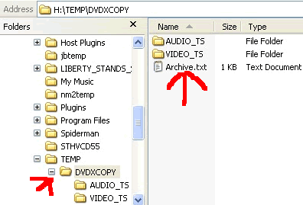
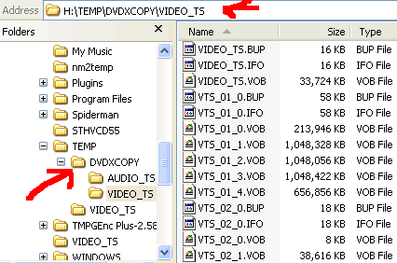
3. The 321Studio warning is located in the VIDEO_TS.VOB file.
4. Run VOBrator and open VIDEO_TS.VOB. Find the VOBID that is the is the 321 disclaimer. Start with VOB ID=1 and PLAY each .VOB. You must have an MPEG codec installed to view the .VOB. If you do not have an codec installed you will get an error message "unable to render graph" or something like this. One option is to install the elcard mpeg player.
With Gladiator it was ID=5 that had the 321 disclaimer. Write down this information for later use in IfoEdit.
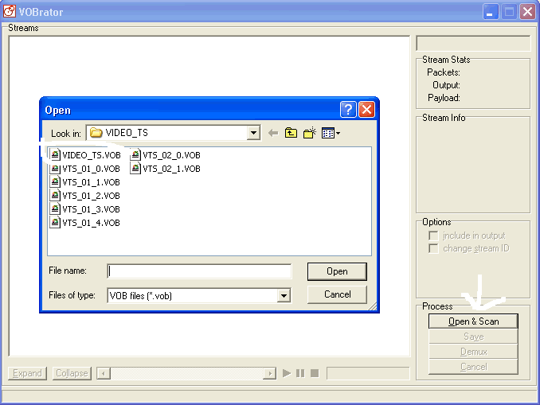
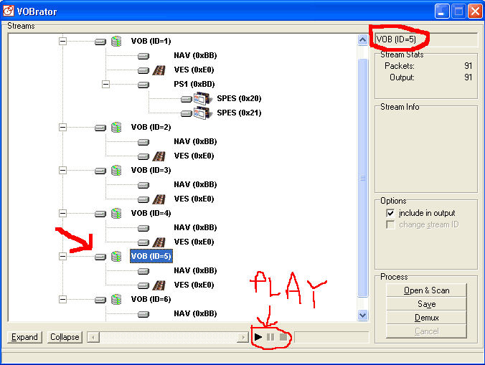
5. For Gladiator there is an FBI warning also. Using VOBrator open the file VTS_01_0.VOB. The FBI warning is on ID=15. Write this information down.
NOTE: your main movie may not be VTS_01_0.VOB but VTS_05_0.VOB. So chose the correct .VOB for your movie.
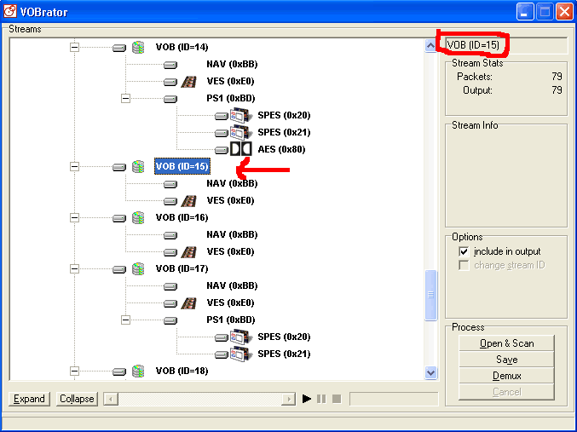
6. Your movie may contain other Welcome Screens, copyright warning or LOGOs that you want to remove from playback. Use the above method to find the ID's for later removal in IfoEdit.
7. Now run IfoEdit and open VIDEO_TS.IFO from the directory that DVDXCOPY created. Scroll down the VMG_OVERVIEW to the 'Language Menu Unit' section. Now look for (uses VOB-ID's :5). Now click on this line to high light it then press the button 'DELETE PLAYBACK'. Save the .IFO and .BUP file, overwriting the existing file in the directory that DVDXCOPY put the 1st half of the move. The 321Studio disclaimer is gone from playback!
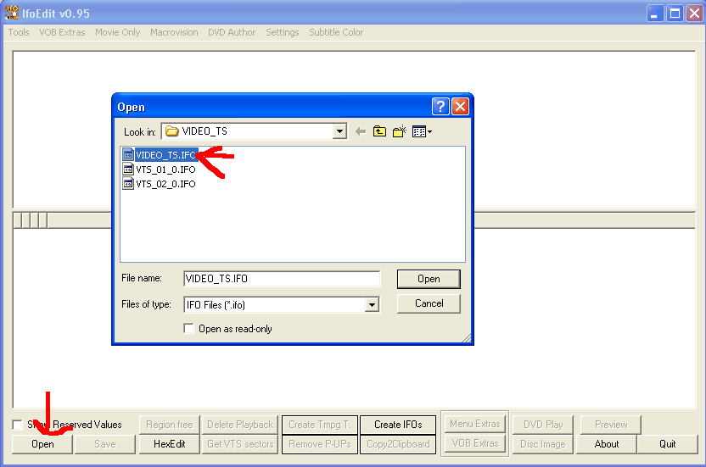
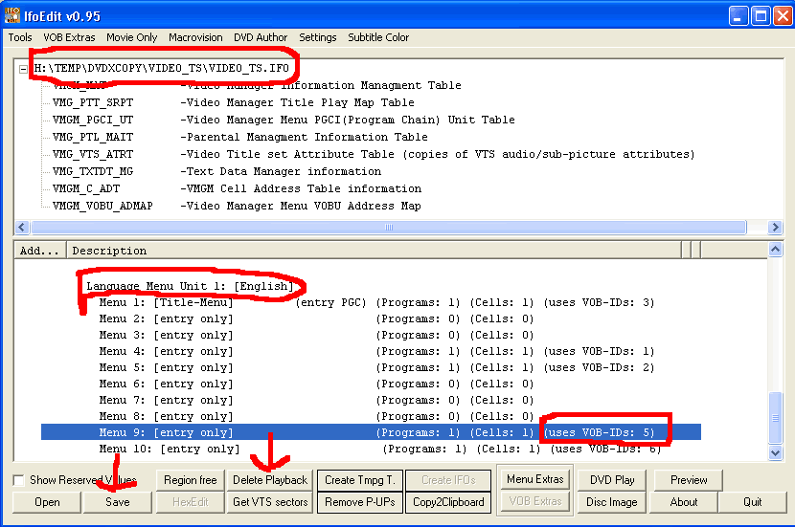
8. Repeat the above process for the VTS_01.0.IFO file which contained the FBI warning. For the Gladiator it was ID=15. Also ID=16 was associated with 15 so one delete kills them both by pressing the 'DELETE PLAYBACK' button. Be sure and SAVE the .IFO and .BUP files.
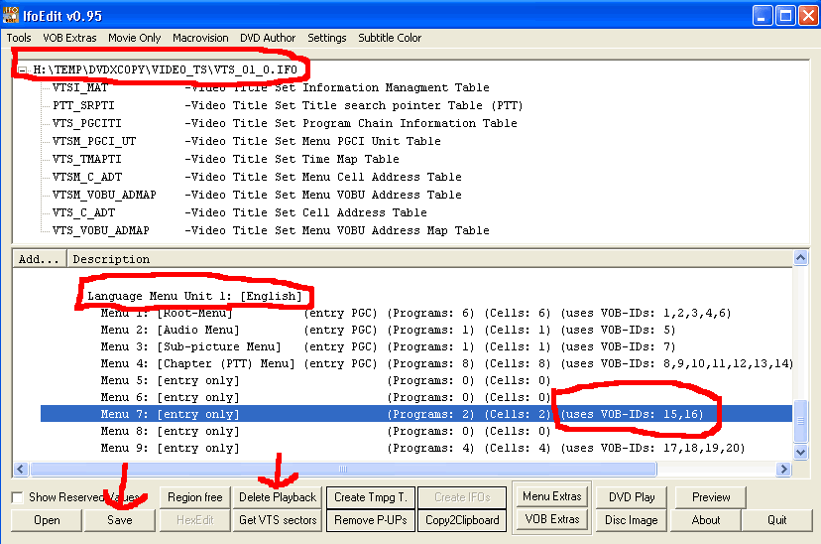
9. Finally there is a ARCHIVE.TXT file located in the directory that DVDXCOPY created the first half of the movie. Delete this file.
10. Go back to DVDXCOPY and follow the BURN method you desire.
This method removes the warnings for DVD 1. I did not take the time to do DVD 2 but the same procedure will work on this one also.
Following the above procedures now allows DVDXCOPY to copy a copy as it doesn't know that it was not an original! There are much better methods to use to do a DVD copy after you have ripped the protection.
This process should take about 5 minutes depending on how many times VOBrator quits on you!
View user comments or post your own comments/issues about this guide here.

