How to convert Video:

1、Supported Video Format：

The movie player in this player need to convert Video format for playing, it supports different kinds of video formats as follows：
RAW、AVI、DIVX、MICROSOFT、INTEL INDEO、WMV、MPG

2、Convert Video format

It has provided video formats in the gift disc, no need to install; you can use it just after copying into your computer. For example, copy the whole file folder (“sigmatel Video Converting Tool”) into the catalog “c:\program files\”in your computer, then enter the catalog and click video2smv.exe to open the Video converting tool：
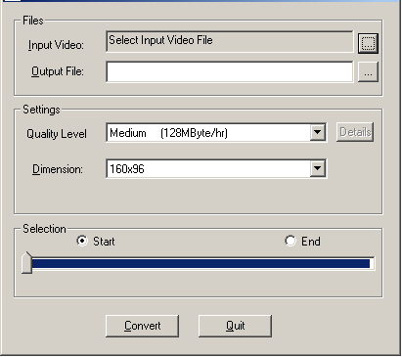

PS:
- Please use the software acquiescence for converting if you are not familiar with Video Convert.

